5.2 Inverse Functions and Their Representations

Inverse Operations
Inverse operations are operations that reverse the effect of another operation. For example:
- The inverse of addition is subtraction.
- The inverse of multiplication is division.
- The inverse of squaring a number is taking the square root.
Inverse operations are useful when solving equations and finding inverse functions.
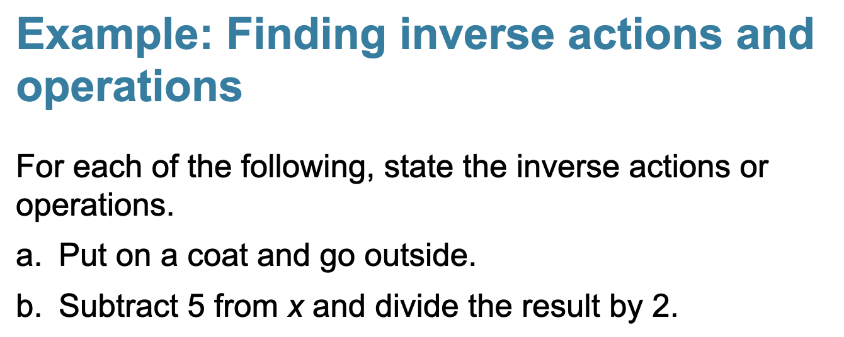

a) go inside, take off your coat.
b) multiply 2, add by 5

f(x) = 3x + 2
multiplying x by 3 and then adding 2.
Inverse: subtract 2 to the result, and then dividing by 3.

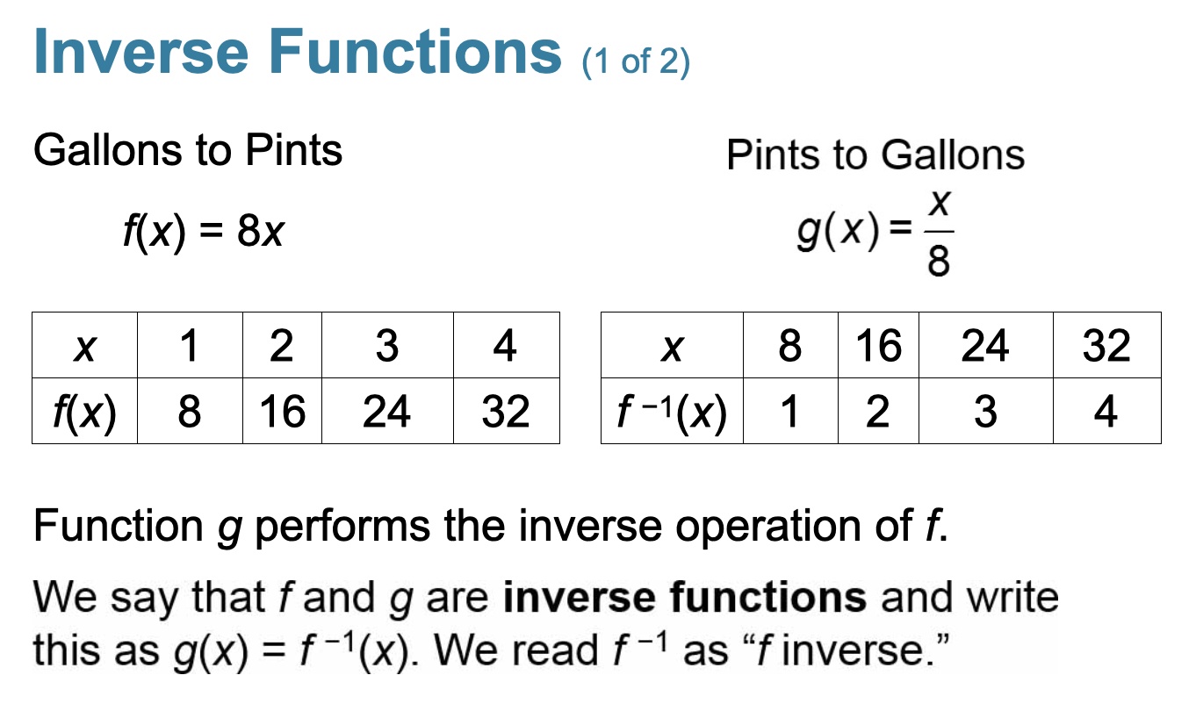
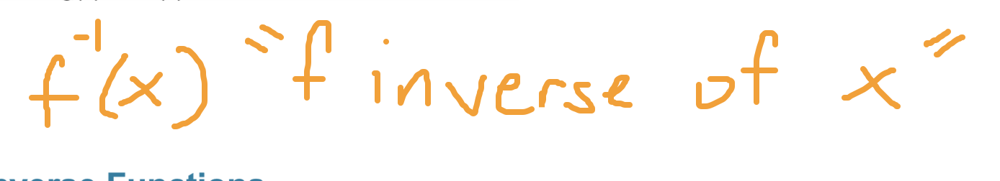

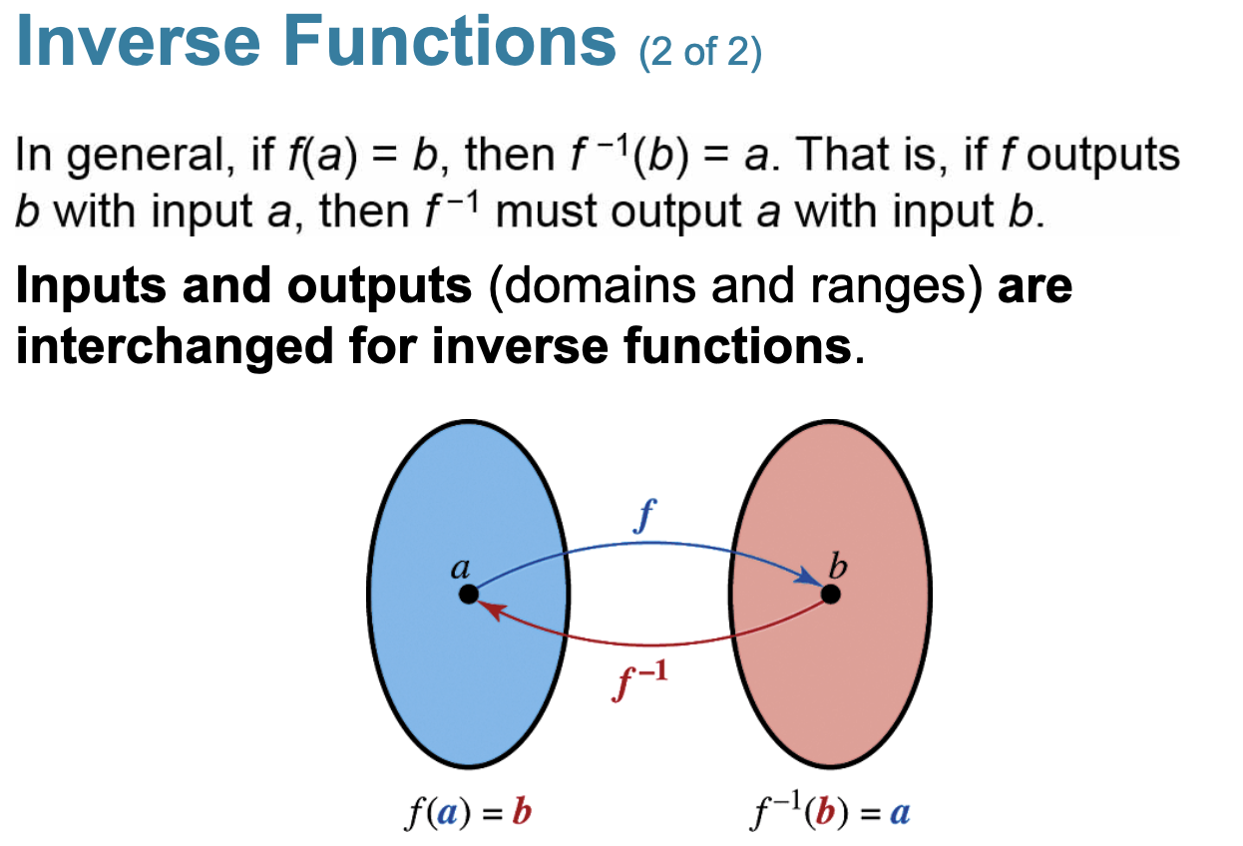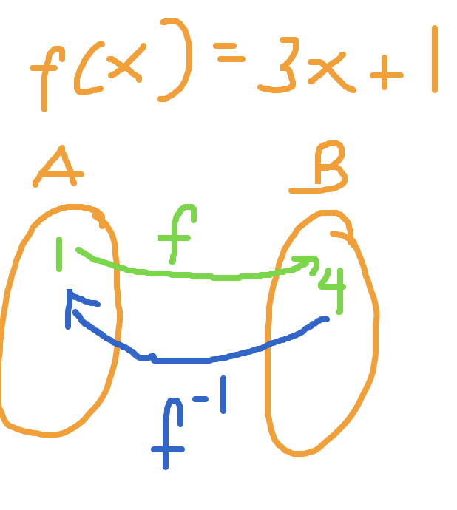

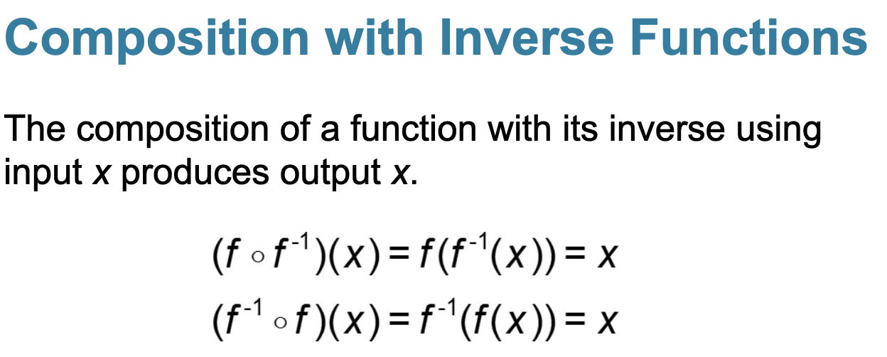

When inverse functions are composed, we get x.

Are f(x) = 3x + 1 and g(x) = x/3 inverses?

Find f(g(x)).
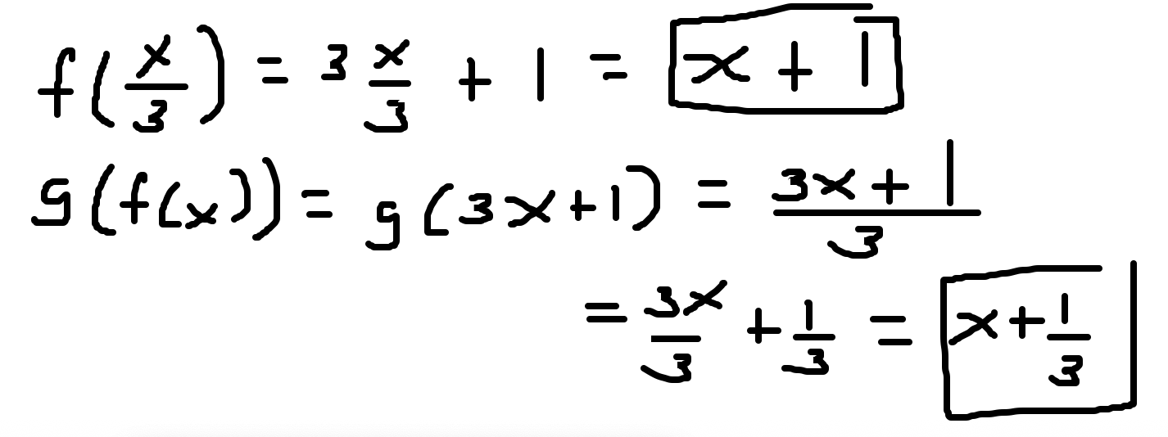

No. f(x) and g(x) are not inverses because when you compose them, we do not get x. (We got x+1, so they are not inverses).

Identifying One-to-One Functions

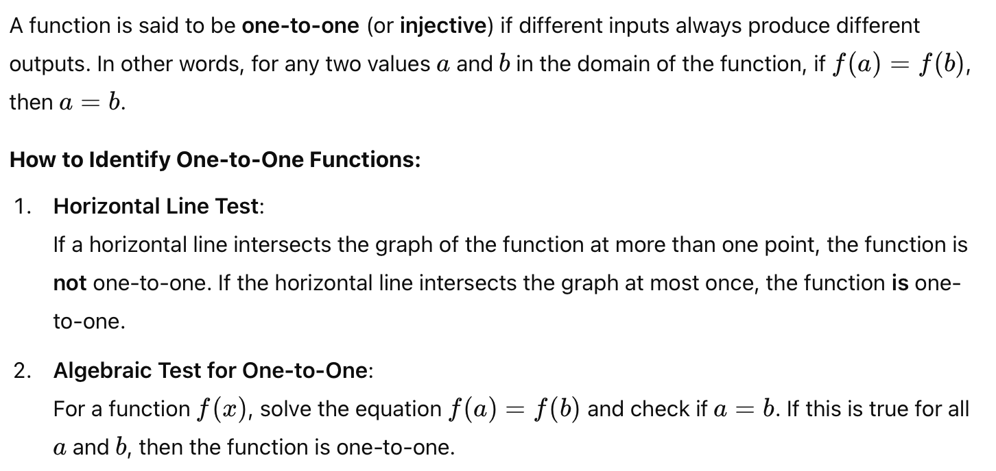

Not all functions have an inverse. To determine if a function has an inverse, you perform the horizontal line test. If you draw a horizontal line through a function and it passes the function more than once, it is not a one-to-one function, and it does NOT have an inverse.

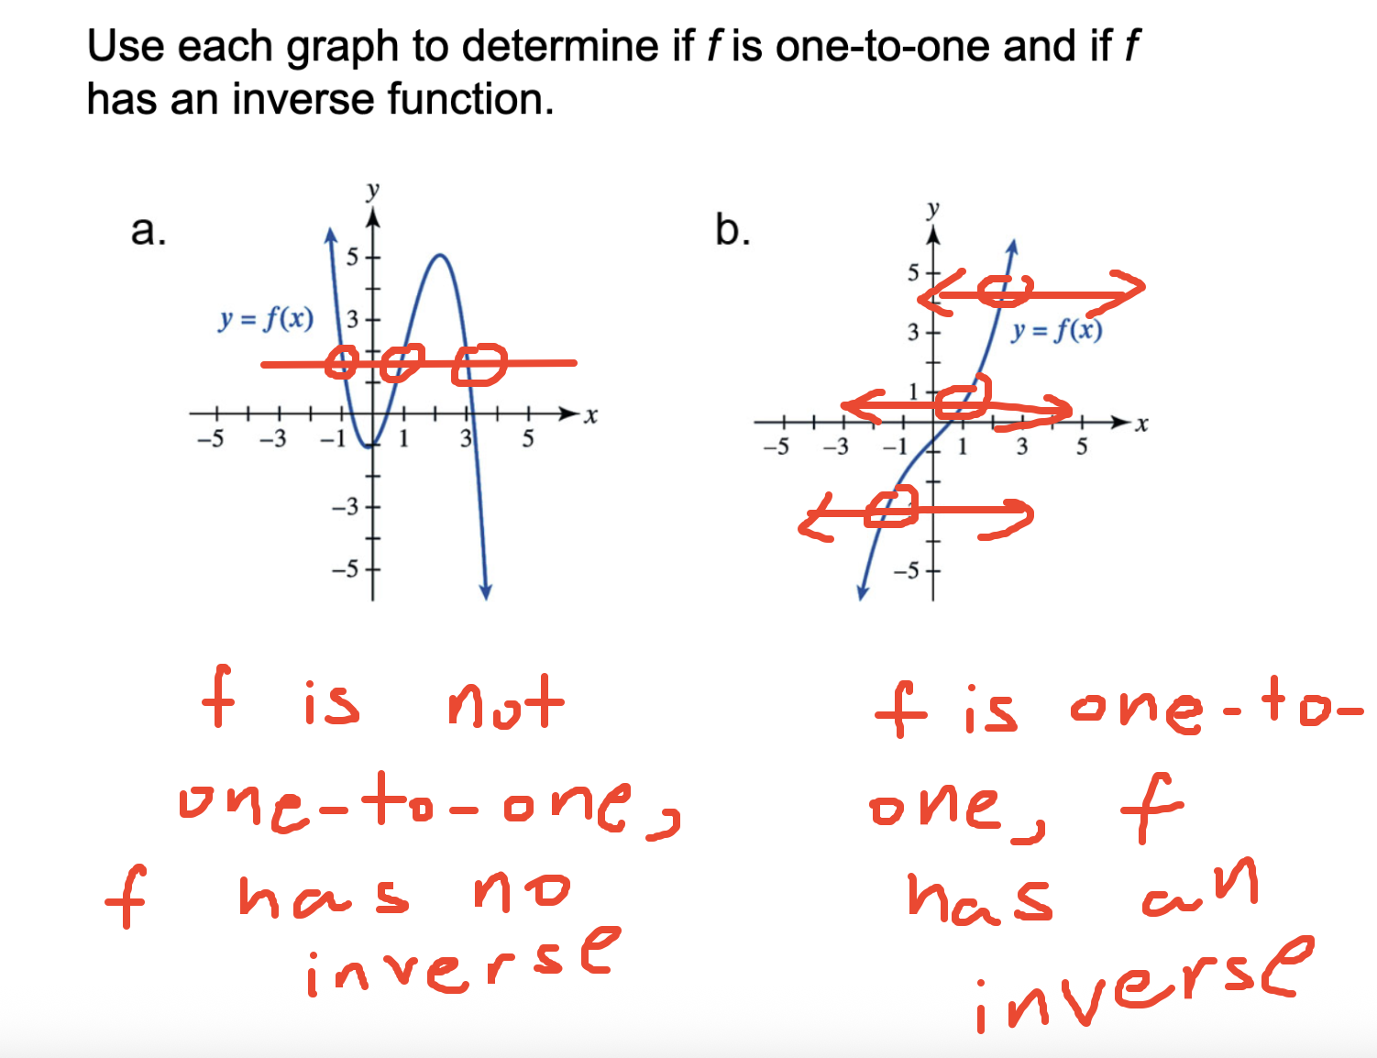

Find Inverse Functions Symbolically
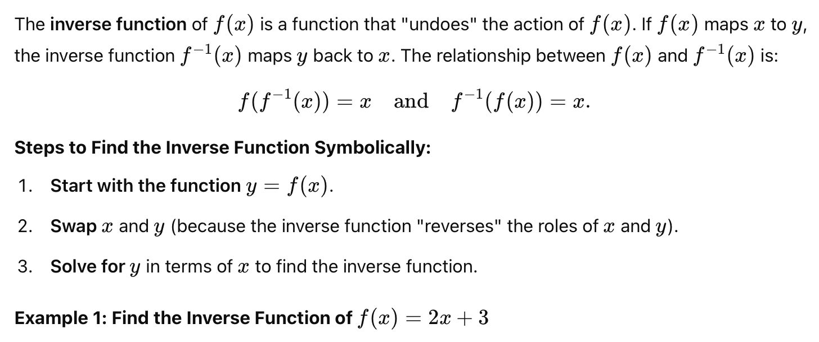
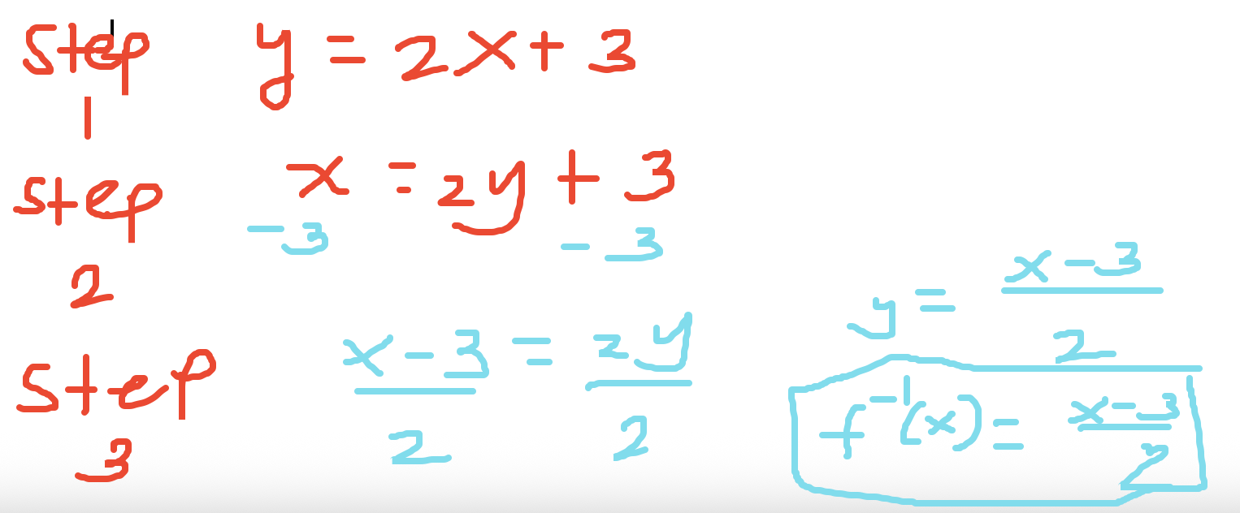

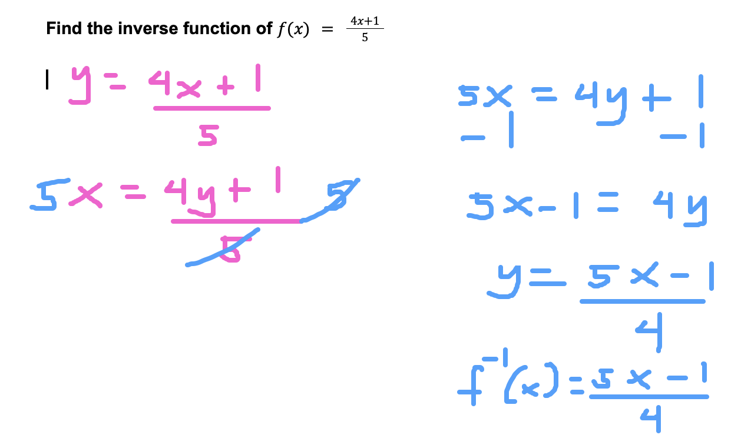

Use Other Representations to Find Inverse Functions
In addition to solving algebraically, there are other ways to find the inverse of a function. For example, we can use graphical methods or tables of values.
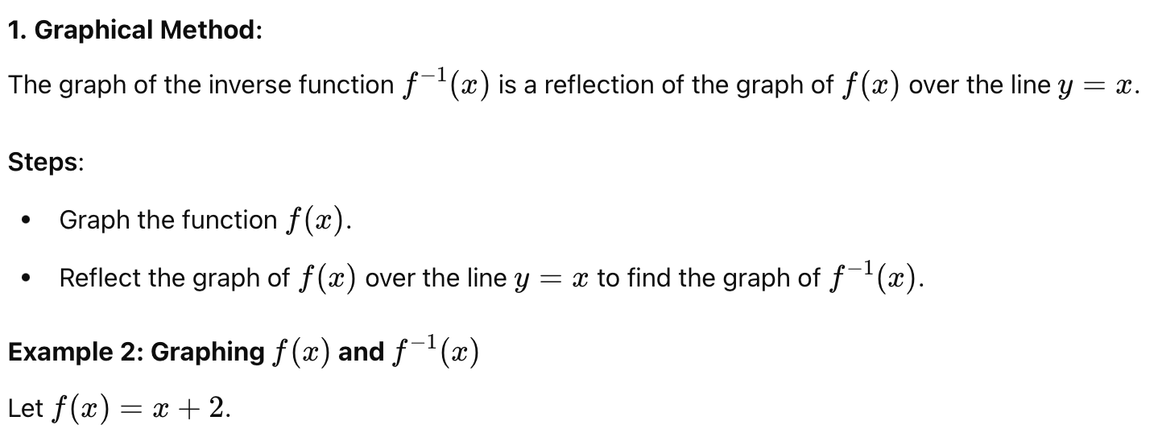

x | 1 | 2
f(x) | 3 | 4

x | 3 | 4
$f^{-1}(x)$ | 1 | 2

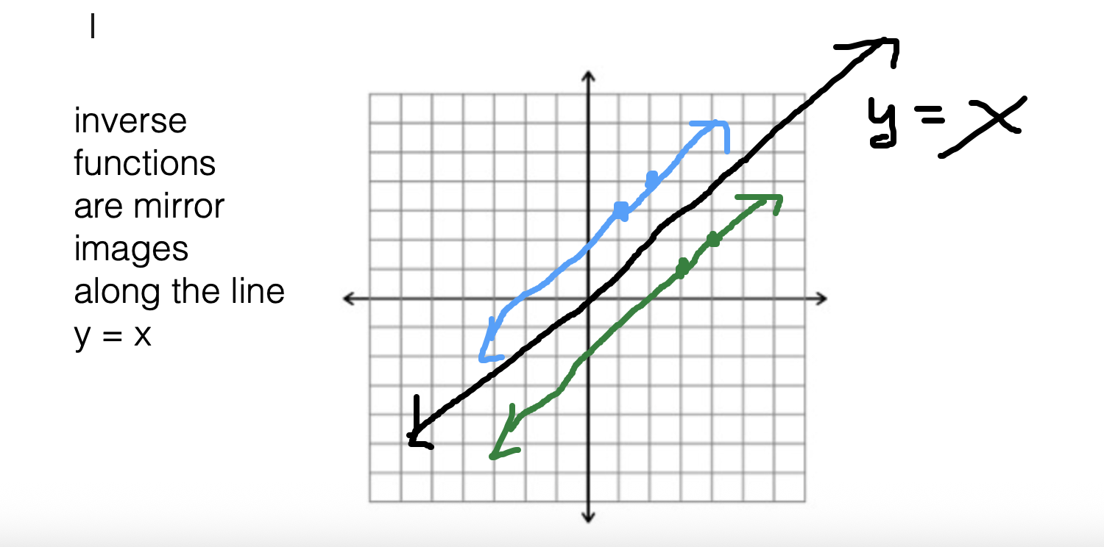

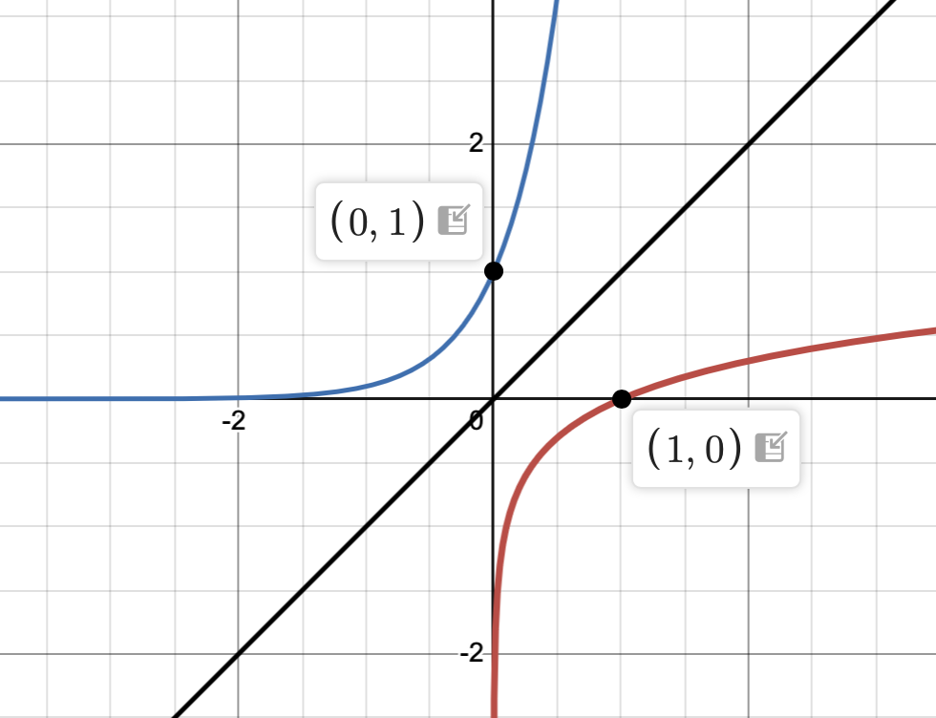

These functions are inverses because they are mirror images of each other. Another property is that if a point (x, y) is on one of the functions, the point (y, x) should be on the other.

Since (0, 1) is on one function, (1, 0) should be on its inverse function.

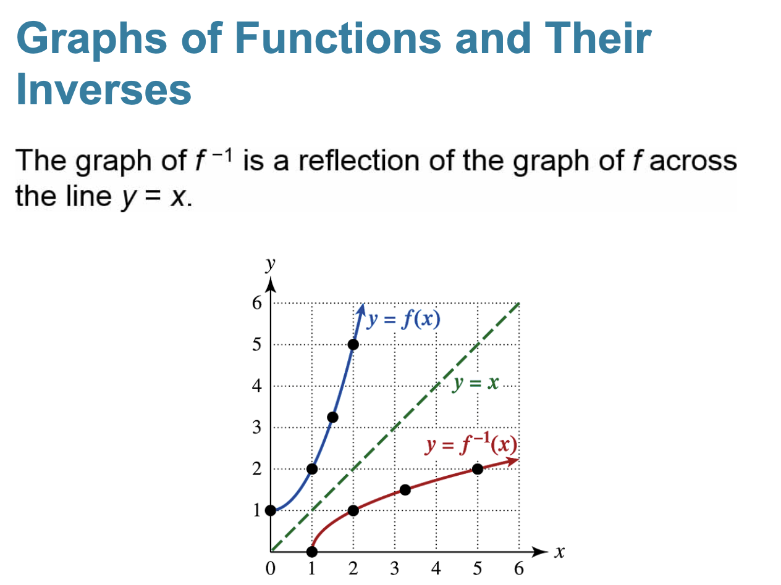

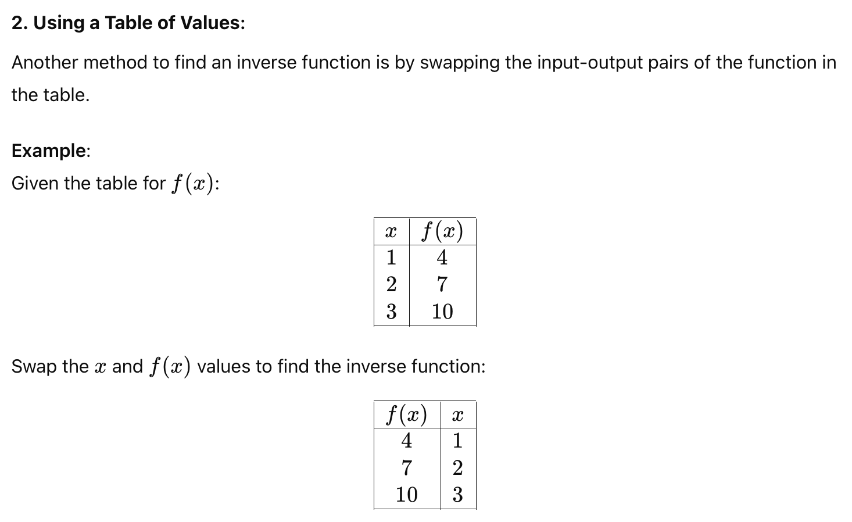

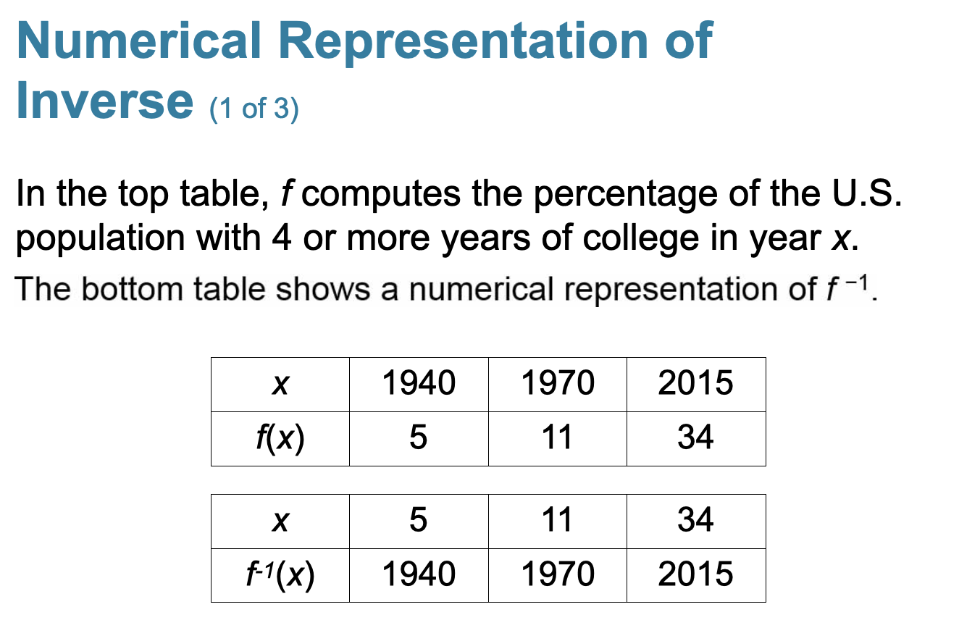

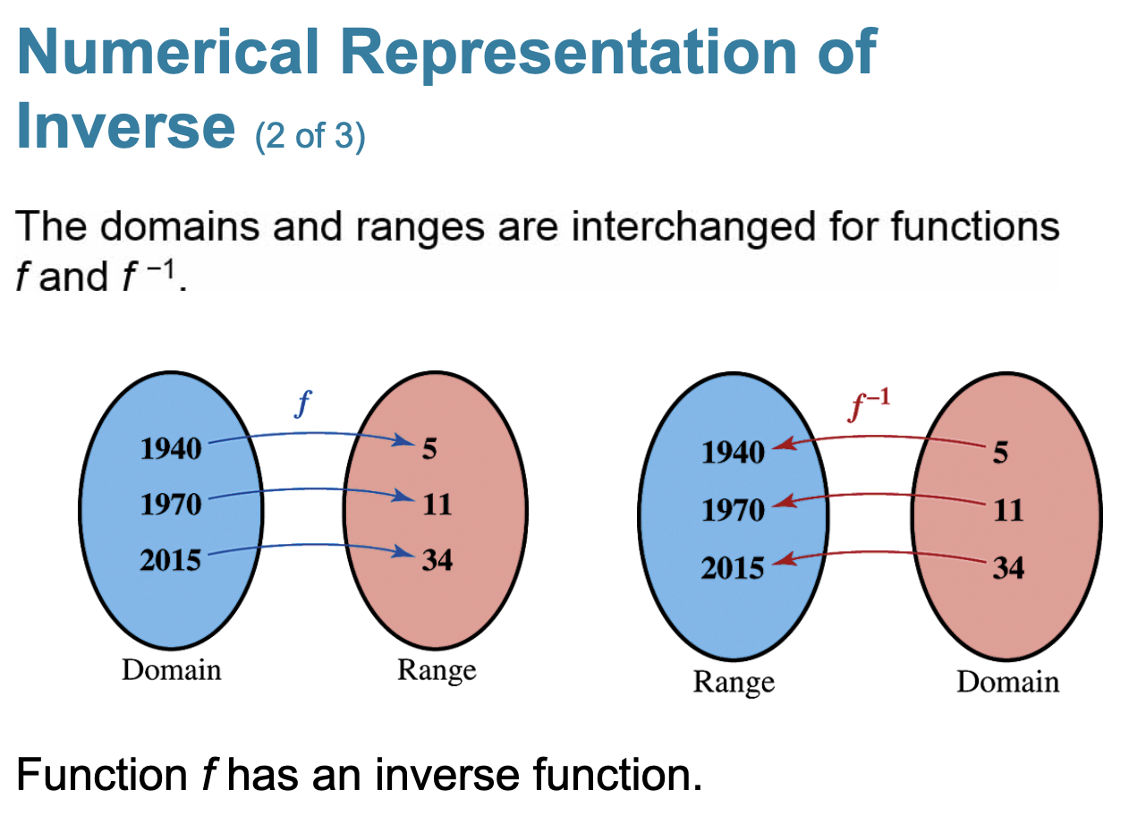

If the domain of f is X and the range of f is Y.
Then the domain of $f^{-1}$ is Y and the range is X.

Ex:
Domain of f: [2, 7]
Range of f: (-infinity, infinity)

Domain of its inverse: (-infinity, infinity)
Range of its inverse: [2, 7]

